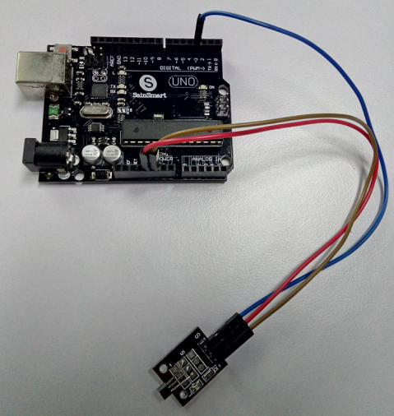

int Led = 13 ;// define LED Interface

int SENSOR = 3 ;// define the Hall magnetic sensor interface

int val ;// define numeric variables val

void setup ()

{

pinMode (Led, OUTPUT) ;// define LED as output interface

pinMode (SENSOR, INPUT) ;// define the Hall magnetic sensor output interface

}

void loop ()

{

val = digitalRead (SENSOR) ;// read digital interface is assigned a value of 3 val

if (val == HIGH) // When the shock sensor detects a signal, LED lights

{

digitalWrite (Led, HIGH);

}

else

{

digitalWrite (Led, LOW);

}

}